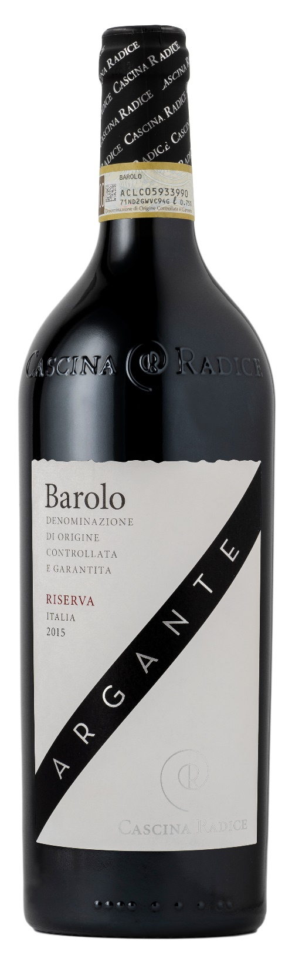
BAROLO DOCG RISERVA - ARGANTE

Grape: Nebbiolo 100%
Alc. Vol.%: 14,5
Vintage: 2019
Residual sugar g/l: 2,0
Total acidity g/l: 5,3
Region: Piedmont
Production zone: Vineyards in the Barolo area (Cuneo)
Capacity: 750ml

CHARACTERISTICS

Vinification: In steel tanks at a controlled temperature. During the 10 days of peel maceration, the must is pumped over twice a day. After the malolactic fermentation, the wine is filled into oak barrels
Aging: 5 years in oak barrels and steel tanks
Yield per ha: 8000kg
Soil composition: Sedimentary sandstone and clay rocks
Colour: Light red with garnet red reflection
Bouquet: Complex, with notes of violets, vanilla and chocolate
Flavour: Full-bodied, harmonious and elegant, brilliant finish

SERVING SUGGESTIONS

Best enjoyed with roast, game and truffle dishes.
Serving temperature 20 °C, to be decanted.
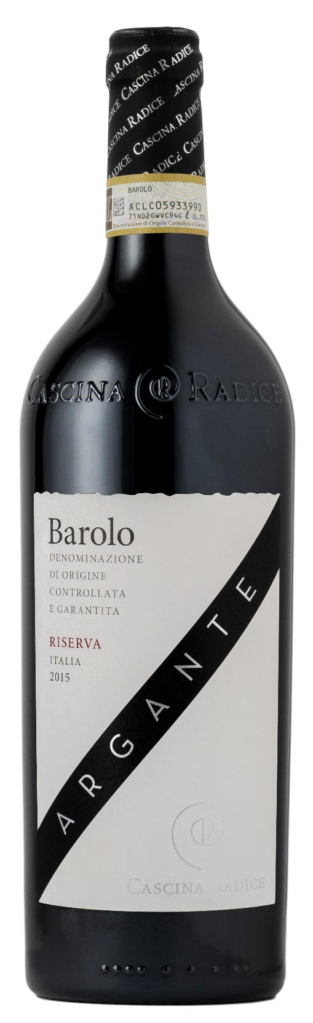
TECHNICAL INFORMATION / PALLETIZING

Size 750ml:
Article Nr. V02002A
GTIN-13 bottle 8017868003670
GTIN-13 carton 8017868002185
Closure Cork
Bottles / carton 6 bottles
Pallet size 80x120cm
Cartons/layer 10
Cartons/pallet 80
Kg/carton 10,10
Kg/pallet 830

Contains sulphites
GMO Free
Revisione 01. 21.04.2026

